Exp No : 1

Date : 08/02/2019

Aim :  Getting started with Linux basic commands for directory operations, displaying directory  
structure in tree format etc.

Command 1 : pwd (Print working directory)

Purpose of command : To know which directory you are in.This command gives the absolute path.

Usage : pwd

Sample I/p and Output

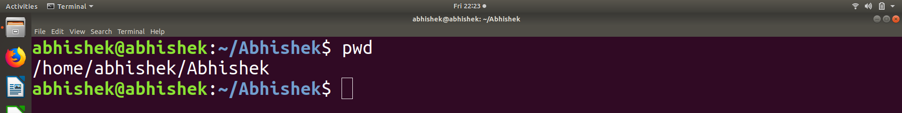Command 2 : ls

Purpose of command : To know what files are in the directory

Usage : ls

ls -a (To show hidden files)

Sample I/p and Output:



Command 3 : cd

Purpose of command : To go to a directory.

Usage : cd “filename”

cd .. (To go to the previous directory)

Sample I/p and Output:

Command 4 :mkdir(make directory) ,rmdir (remove directory)

Purpose of command : mkdir =To make a directory,rmdir= To remove directory.

Usage : mkdir “Filename”

Rmdie “filename”

Sample I/p and Output:

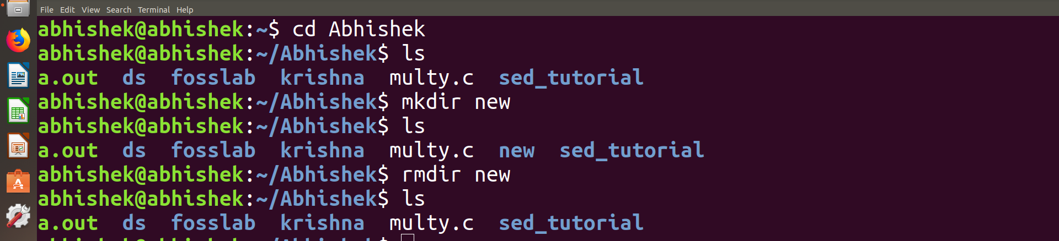

Command 5 : rm

Purpose of command : Delete files and directory.

Usage : rm “filename” (To remove a file)

rm -r “directory name” (To remove a directory)

Sample I/p and Output:

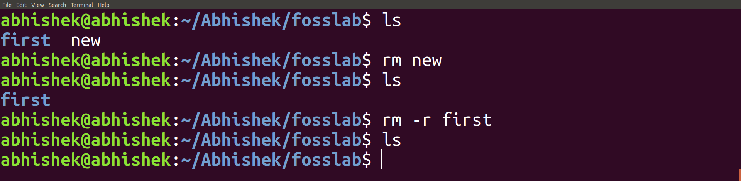

Command 6 : touch

Purpose of command : create a file.

Usage : touch “Filename”

Sample I/p and Output

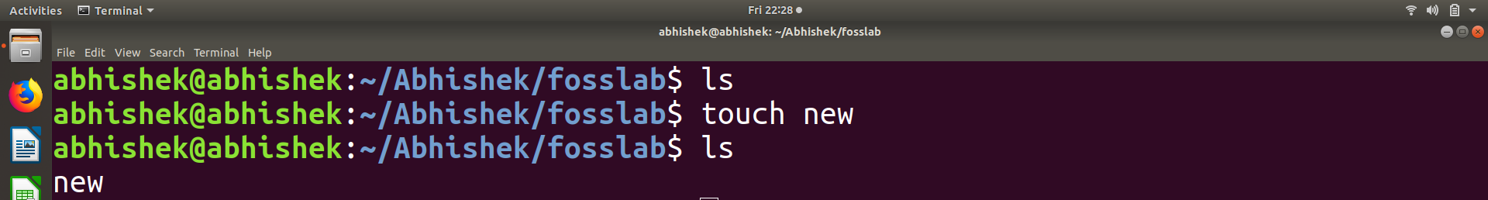

Command 7 : cp

Purpose of command : copy files through command line.

Usage :cp “location of the file to be copied” “where to copy”

Sample I/p and Output:

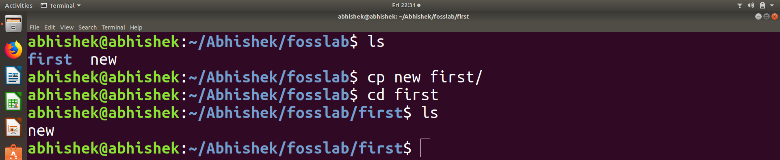

Command 8 : mv

Purpose of command : move files through command line.

Usage :mv “location of the file to be moved” “where to move”

Sample I/p and Output:

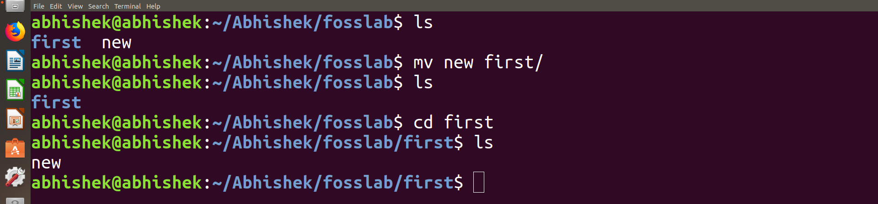

Command 9 : cat

Purpose of command : Display the content of a file

Usage : cat “filename”

Sample I/p and Output:

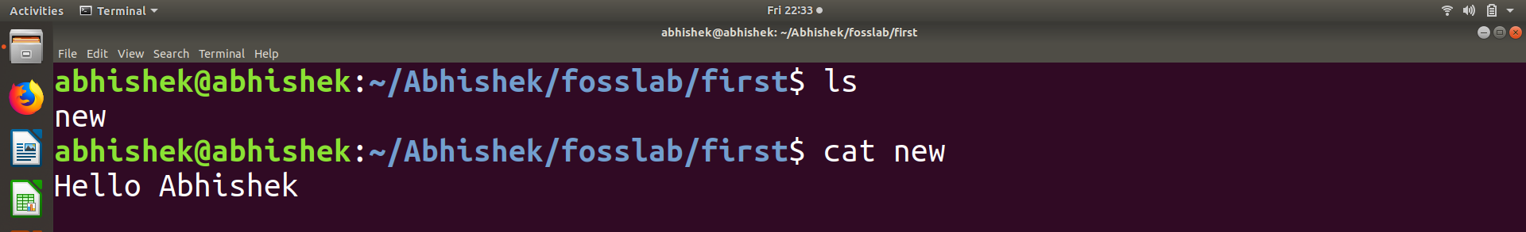

Command 10 : echo

Purpose of command : Help us move some data, usually text into a file.

Usage :echo “content” “filename”.

Sample I/p and Output:

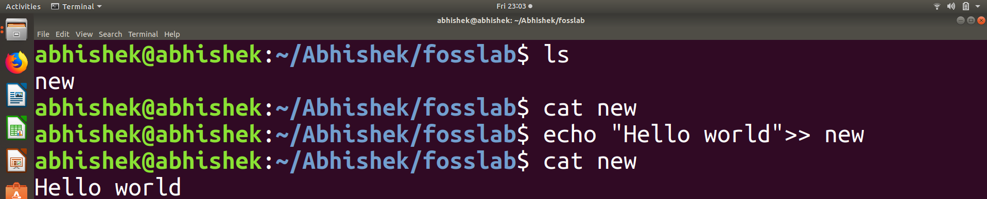

Conclusion

Linux basic commands like cd,ls helps us to navigate through locations and other commands like mv,cp,cat helps us to do some basic operations.